September 2018
Dear Families,
Welcome to 3rd grade! My name is Miss Nicole Webb and I will be your child’s teacher for the 2018-2019 school year. I am excited to welcome you and your child to my classroom.
  - Please send a healthy snack in each day with your child.
  - Your child will be receiving a homework agenda to record daily assignments and reminders. Please initial their agenda each night and have them return it with the assignments each day.
  - Students should be reading a book of their choice for AT LEAST 20 minutes each night!
  - If you have not already done so, please familiarize yourself with the Parent Portal and my webpage. I will also be utilizing the Remind app, which you can find more information about by clicking on the “Remind App” tab on my webpage. These will all be instrumental in supporting the district wide paperless initiative while still conveying individual, class, and school information.
If you ever have any questions or concerns, please do not hesitate to contact me. Communication between parents and teachers is an important part of student success!
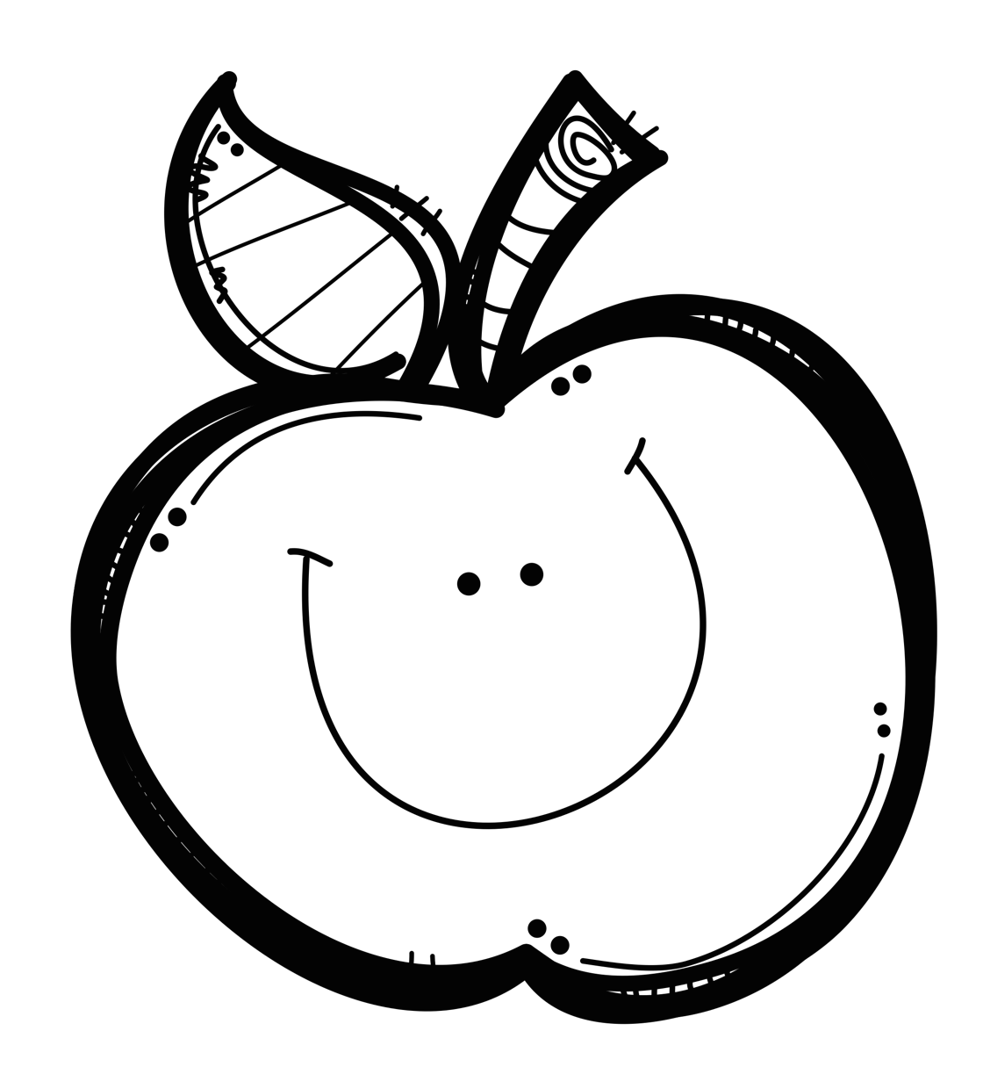
Thank you for sharing your child with me and I look forward to working with you for a successful 2018-2019 year in 3rd grade!

Sincerely,
Miss Nicole Webb
nwebb@wpschools.org

